Marketing Campaign Analysis Report

Analysis of Key Metrics

1. Deal Engagement Analysis

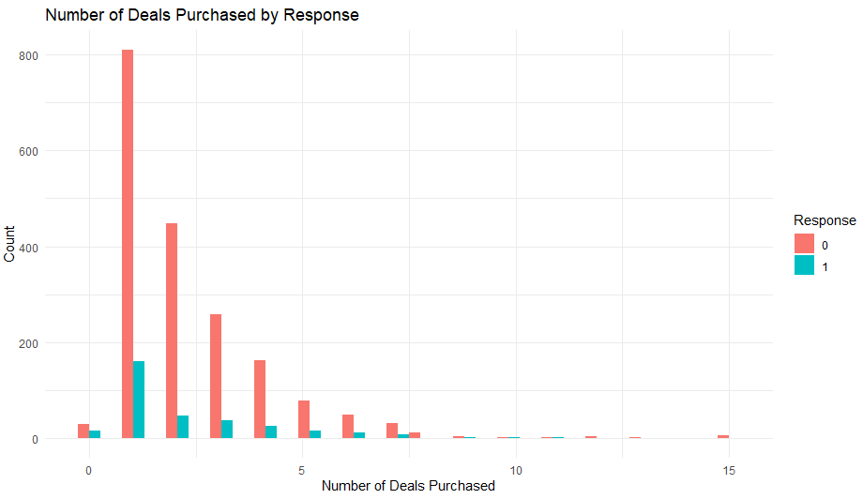

The analysis of deal purchases reveals significant patterns in customer engagement:

\* Most customers participate in 0-5 deals

\* Customers who respond positively to campaigns show higher deal participation

\* Peak response rates occur among customers engaging with 2-4 deals

\* Deal participation shows diminishing returns after 8 deals

\* The stark difference in deal participation between responsive and non-responsive customers suggests deals are an effective engagement tool

2. Spending and Income Relationship

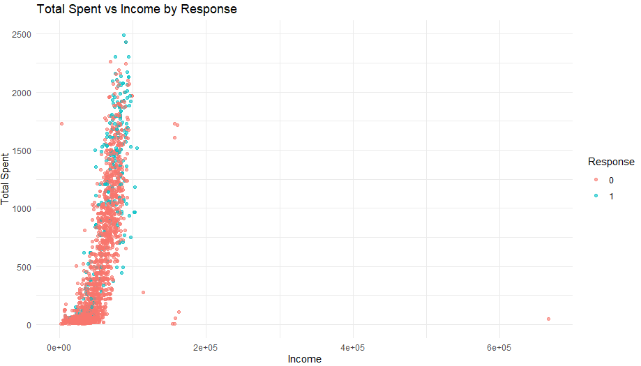

The relationship between customer spending and income shows clear patterns:

\* There exists a strong positive correlation between income and total spending

\* Higher-income customers demonstrate greater likelihood to respond to campaigns

\* Spending patterns are most concentrated in low-to-middle income ranges

\* Notable outliers exist in high-income brackets with exceptional spending behavior

\* The scatter pattern suggests income is a reliable predictor of potential spending

3. Total Spending Distribution

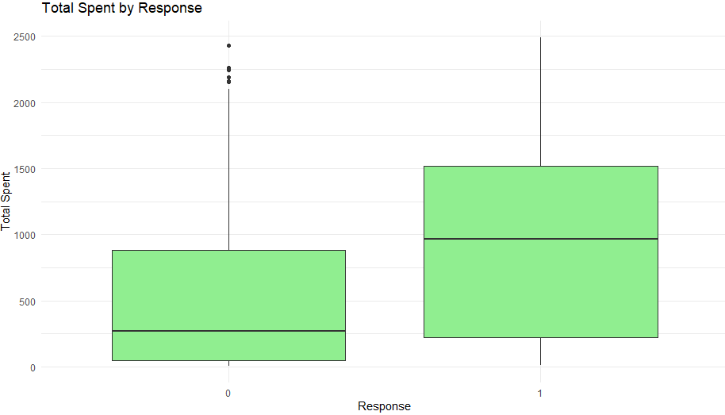

Analysis of spending patterns between responsive and non-responsive customers reveals:

\* Responsive customers maintain significantly higher median spending levels

\* The spending range is broader among responsive customers

\* Both groups show outliers, but responsive customers have more high-value outliers

\* The quartile ranges for responsive customers are notably higher

\* This indicates that high-spending customers are more likely to engage with campaigns

4. Product Category Performance

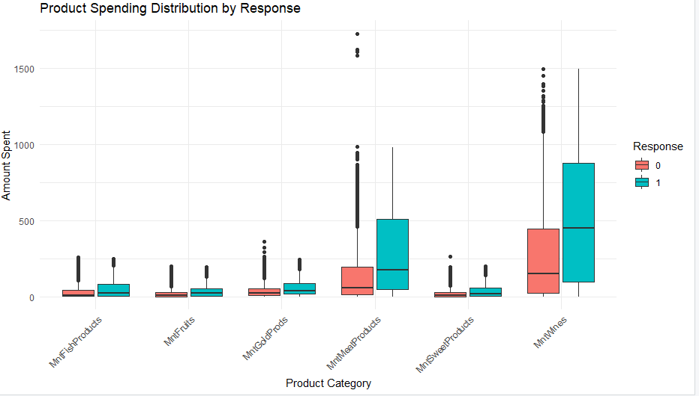

The breakdown of spending across product categories shows:

\* Wines category leads in spending across both customer groups

\* Gold products represent the second-highest spending category

\* Meat and fish products show moderate spending levels

\* Fruits and sweets categories show consistent but lower spending patterns

\* Responsive customers consistently spend more across all product categories

5. Education Level Impact

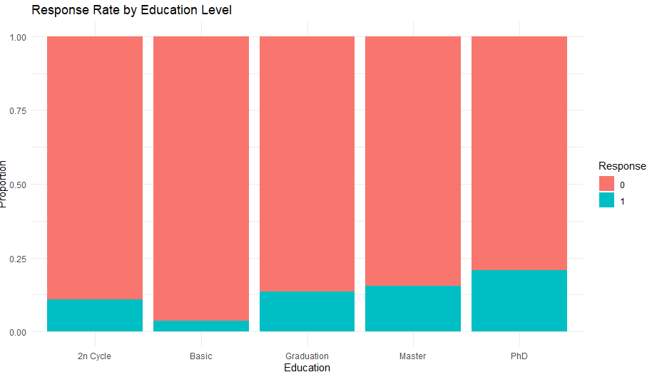

Education level analysis provides valuable insights:

\* PhD holders demonstrate the highest campaign response rates

\* Master's degree holders follow closely in response rates

\* Basic education level shows the lowest response rates

\* A clear positive correlation exists between education level and campaign response

\* This suggests targeting strategies should consider education levels

6. Purchase Channel Effectiveness

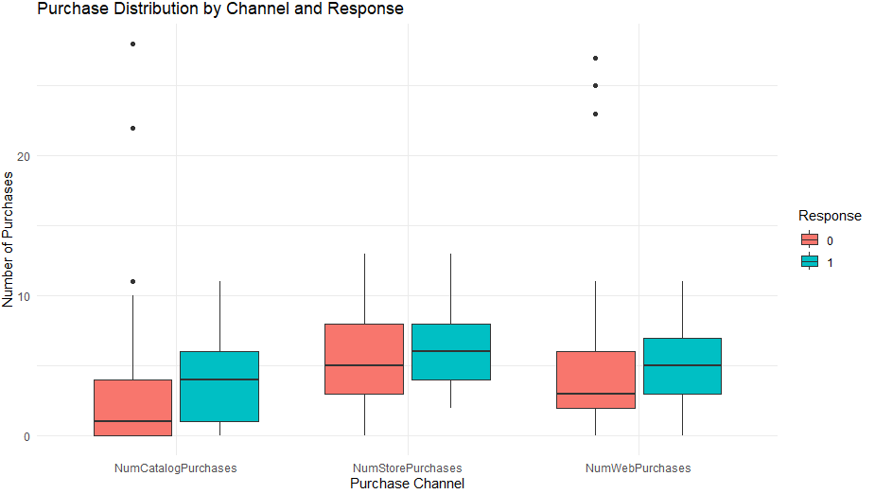

Analysis of purchase channels reveals:

\* Web purchases show the highest overall engagement

\* Store purchases maintain moderate but steady engagement levels

\* Catalog purchases show the most marked difference between responsive and non-responsive customers

\* Responsive customers show higher engagement across all channels

\* This suggests a multi-channel approach is most effective

7. Income Distribution Patterns

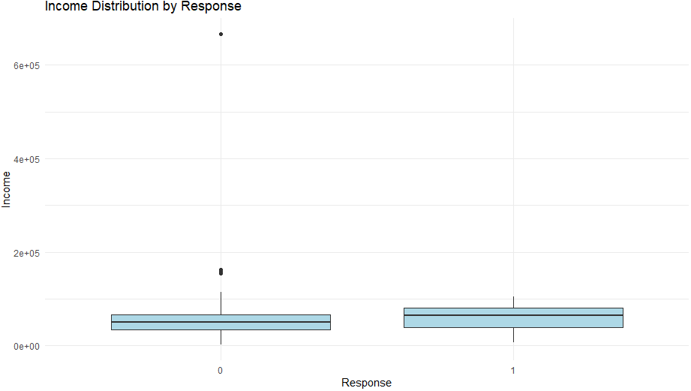

The income distribution analysis shows:

\* Median income levels are similar between responsive and non-responsive groups

\* Responsive customers show slightly higher income variability

\* High-income outliers exist in both groups

\* Income alone isn't a definitive predictor of campaign response

\* This suggests targeting strategies should consider multiple factors beyond income

8. Age Distribution Analysis

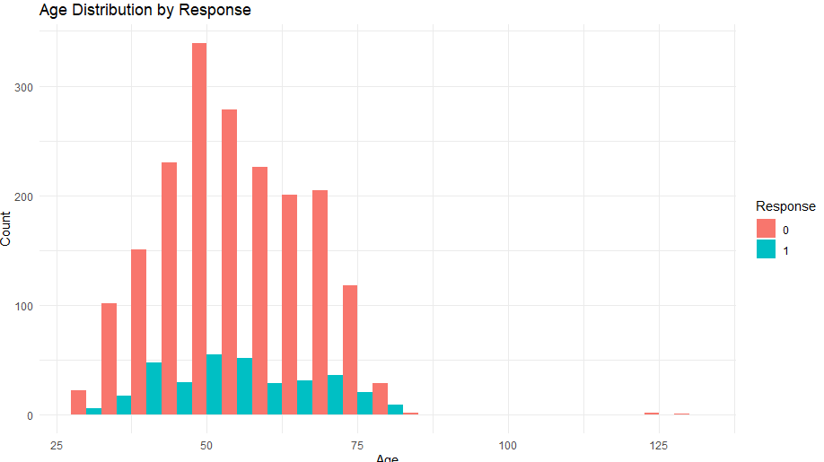

Age distribution patterns reveal:

\* Peak response rates occur in the 45-65 age range

\* Lower response rates among younger customers (25-35)

\* Declining response rates after age 70

\* Middle-aged customers form the core responsive segment

\* This indicates age-targeted campaign strategies may be effective